Elastic Security Analytics Workshop

Lab 4 - Explore Elastic SIEM

Elasticsearch can handle almost any kind of data, including structured and unstructured text, flow data, metrics, geo points, and more. This enables organizations to ingest whatever data they need, regardless of type or origin. Real-time access to log data allows you to filter and locate that one “needle in a haystack” event that could reveal the cause of a security breach.

The [Elastic SIEM](https://www.elastic.co/blog/introducing-elastic-siem) app in Kibana, provides an interactive workspace for security teams to triage events and perform initial investigations, is enabled by Elastic common schema.

# Introduction

In this lab guide we will walk you through the SIEM ui and all its components.

Now that we have data flowing into our stack, we can walk through the different parts of the SIEM ui, which is made up of the following components:

* Overview - This is a break down of events received by the SIEM app. It is split into the respective beats modules
* Hosts - This page shows information about all the reporting hosts. This includes some KPIs to get you started, an authentications table, an Uncommon Processes table, and an events table.
* Network - This view shows all related network activity, similar to the hosts view, it includes some KPIs to get started and some tables related to potential network anomalies such as top talkers and dns queries being made.

## **The Hosts View**

Let’s start trying out the hosts view. If you haven’t already, click on the “SIEM” app in kibana.

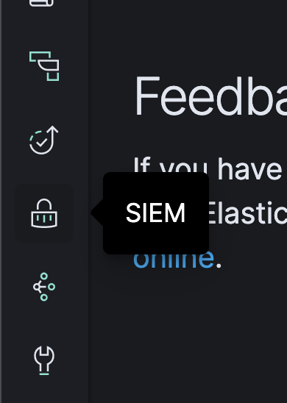

Click on “Hosts” at the top of the screen:

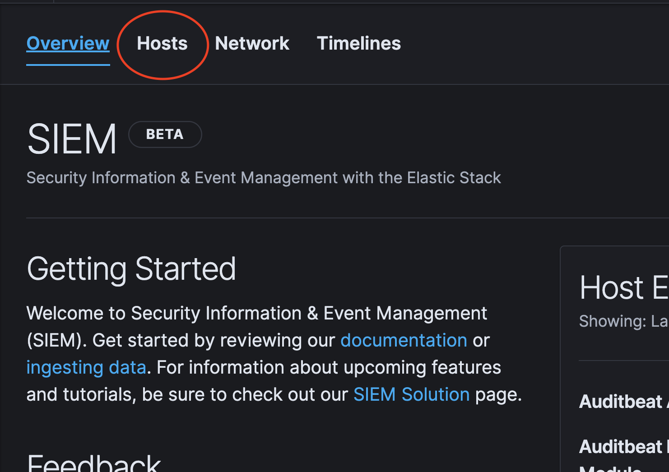

You should now be able to see the populated hosts view with the two VM’s in your lab. The host names should be similar as seen below.

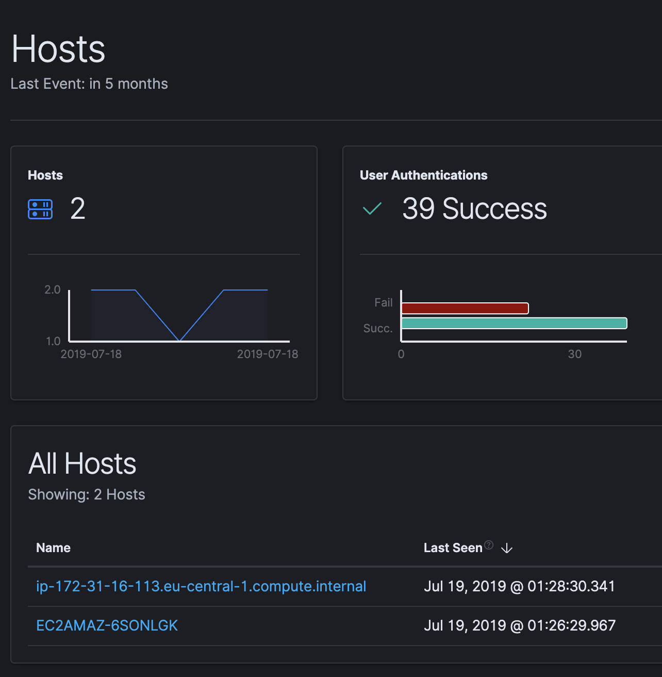

Further down, you will notice the authentication, uncommon process and events tables:

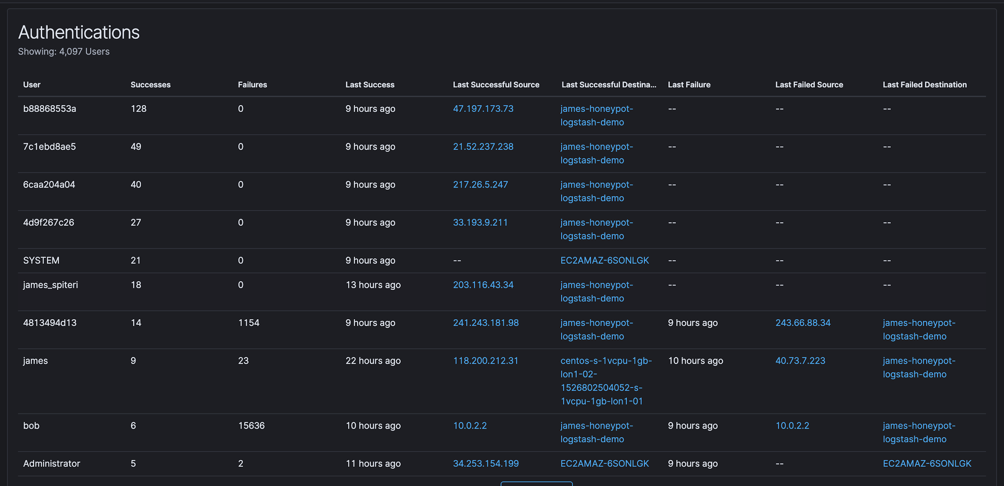

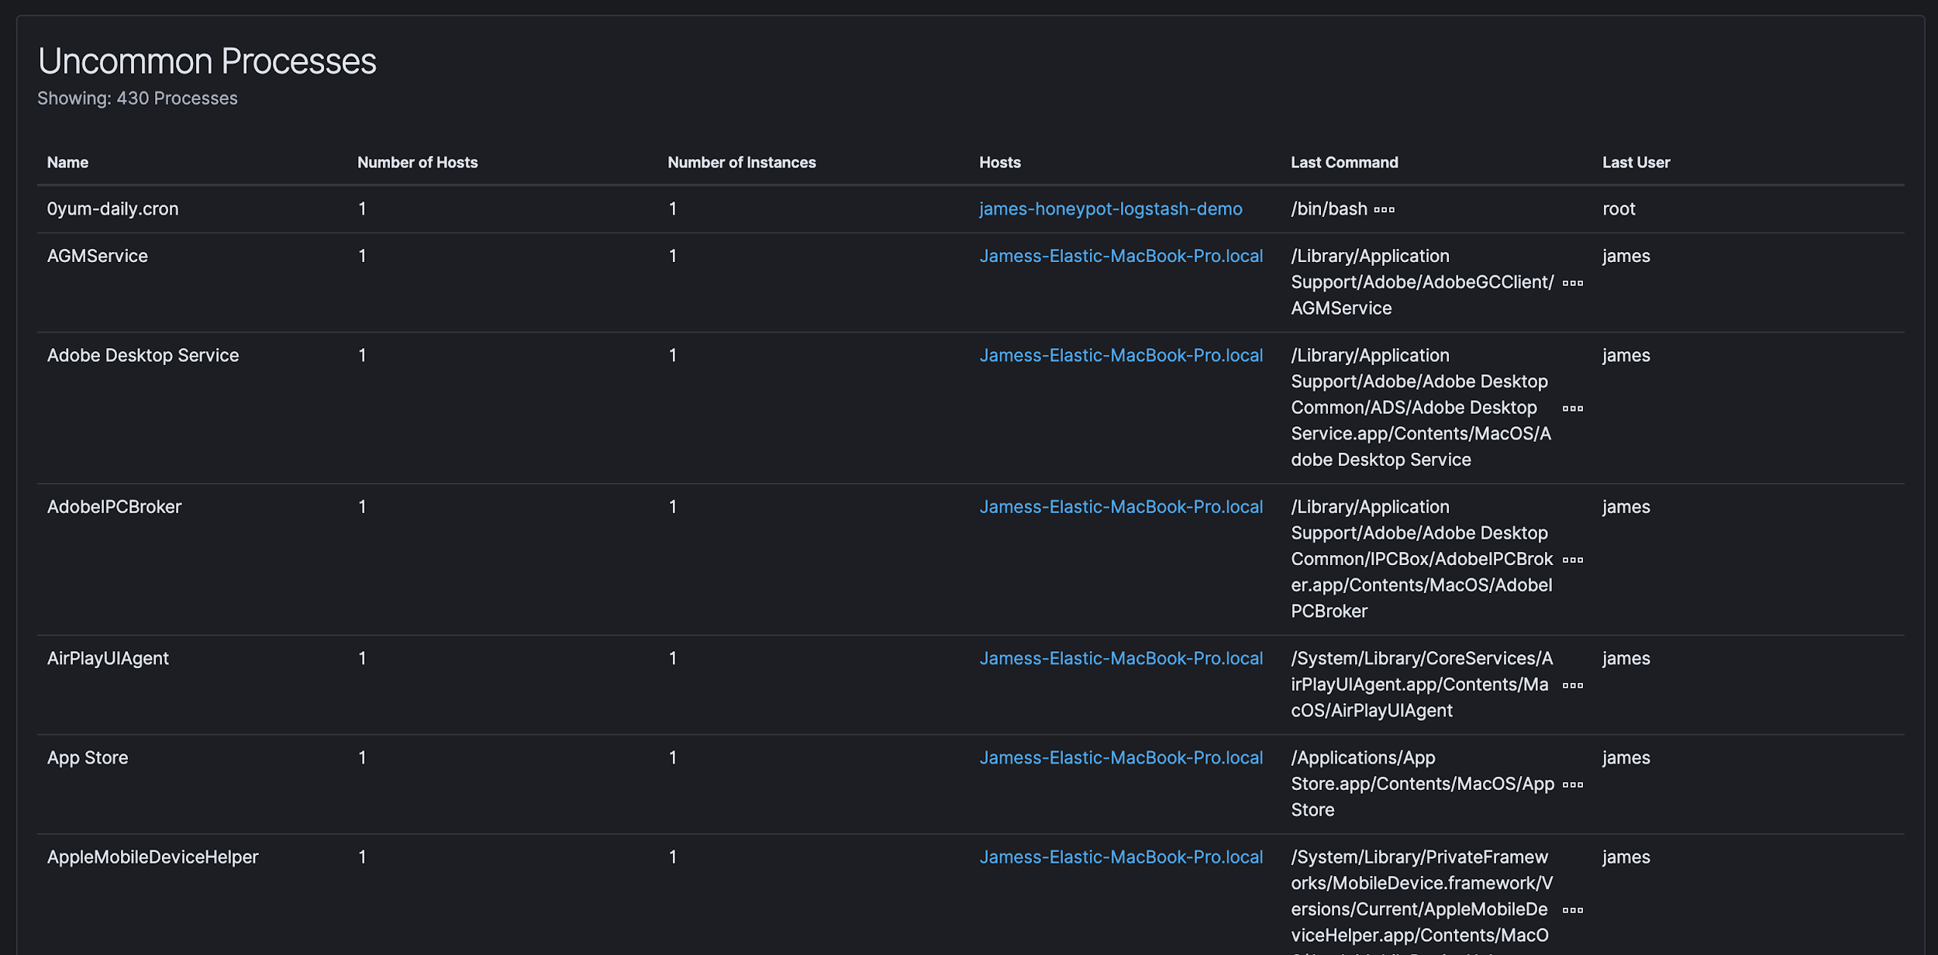

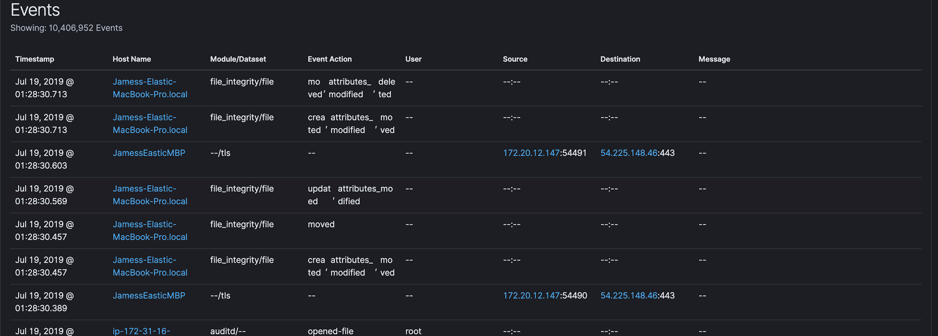

Let’s look at all the host info we get from our beats configuration. Click on any of the two hosts from the hosts table to drill down.

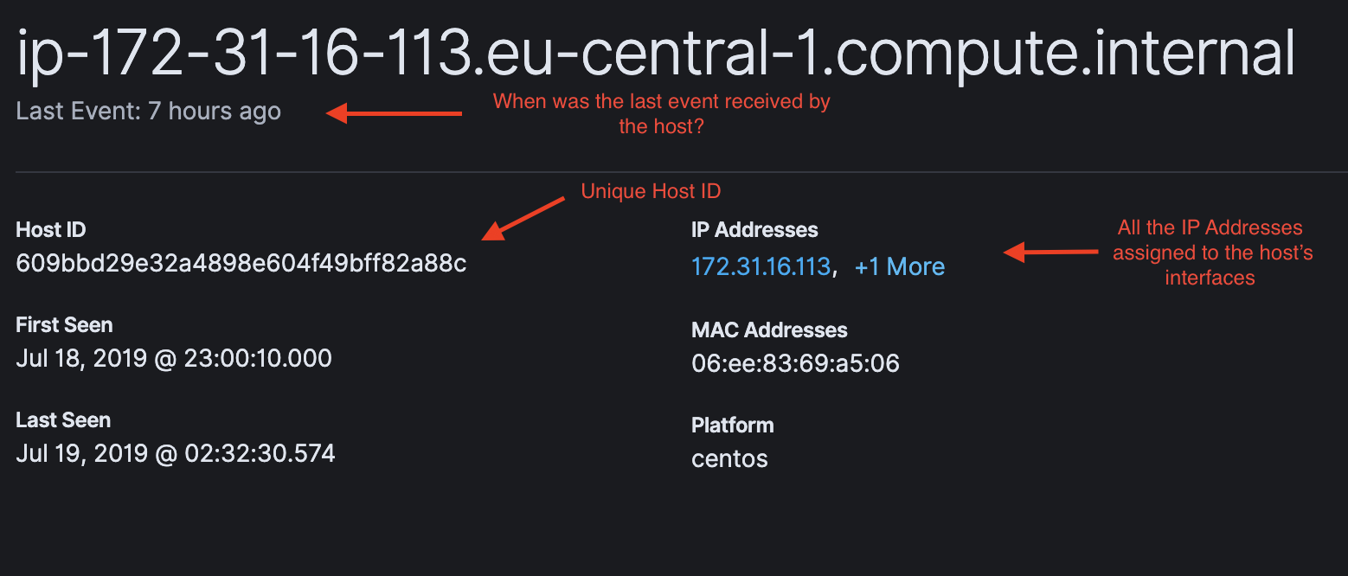

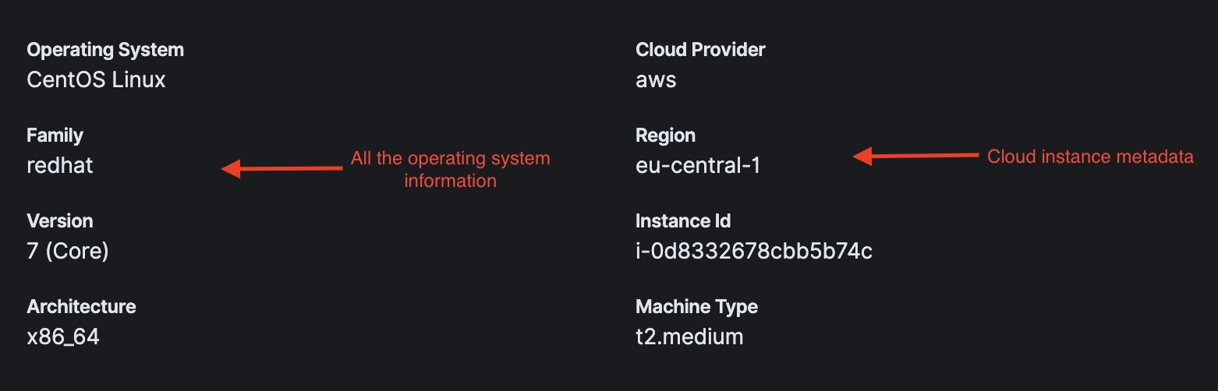

You will notice that the authentications and events table have switched context to this host.

## **The Network view**

Let’s see the information we get in the network view. Switch from the hosts view to the network view.

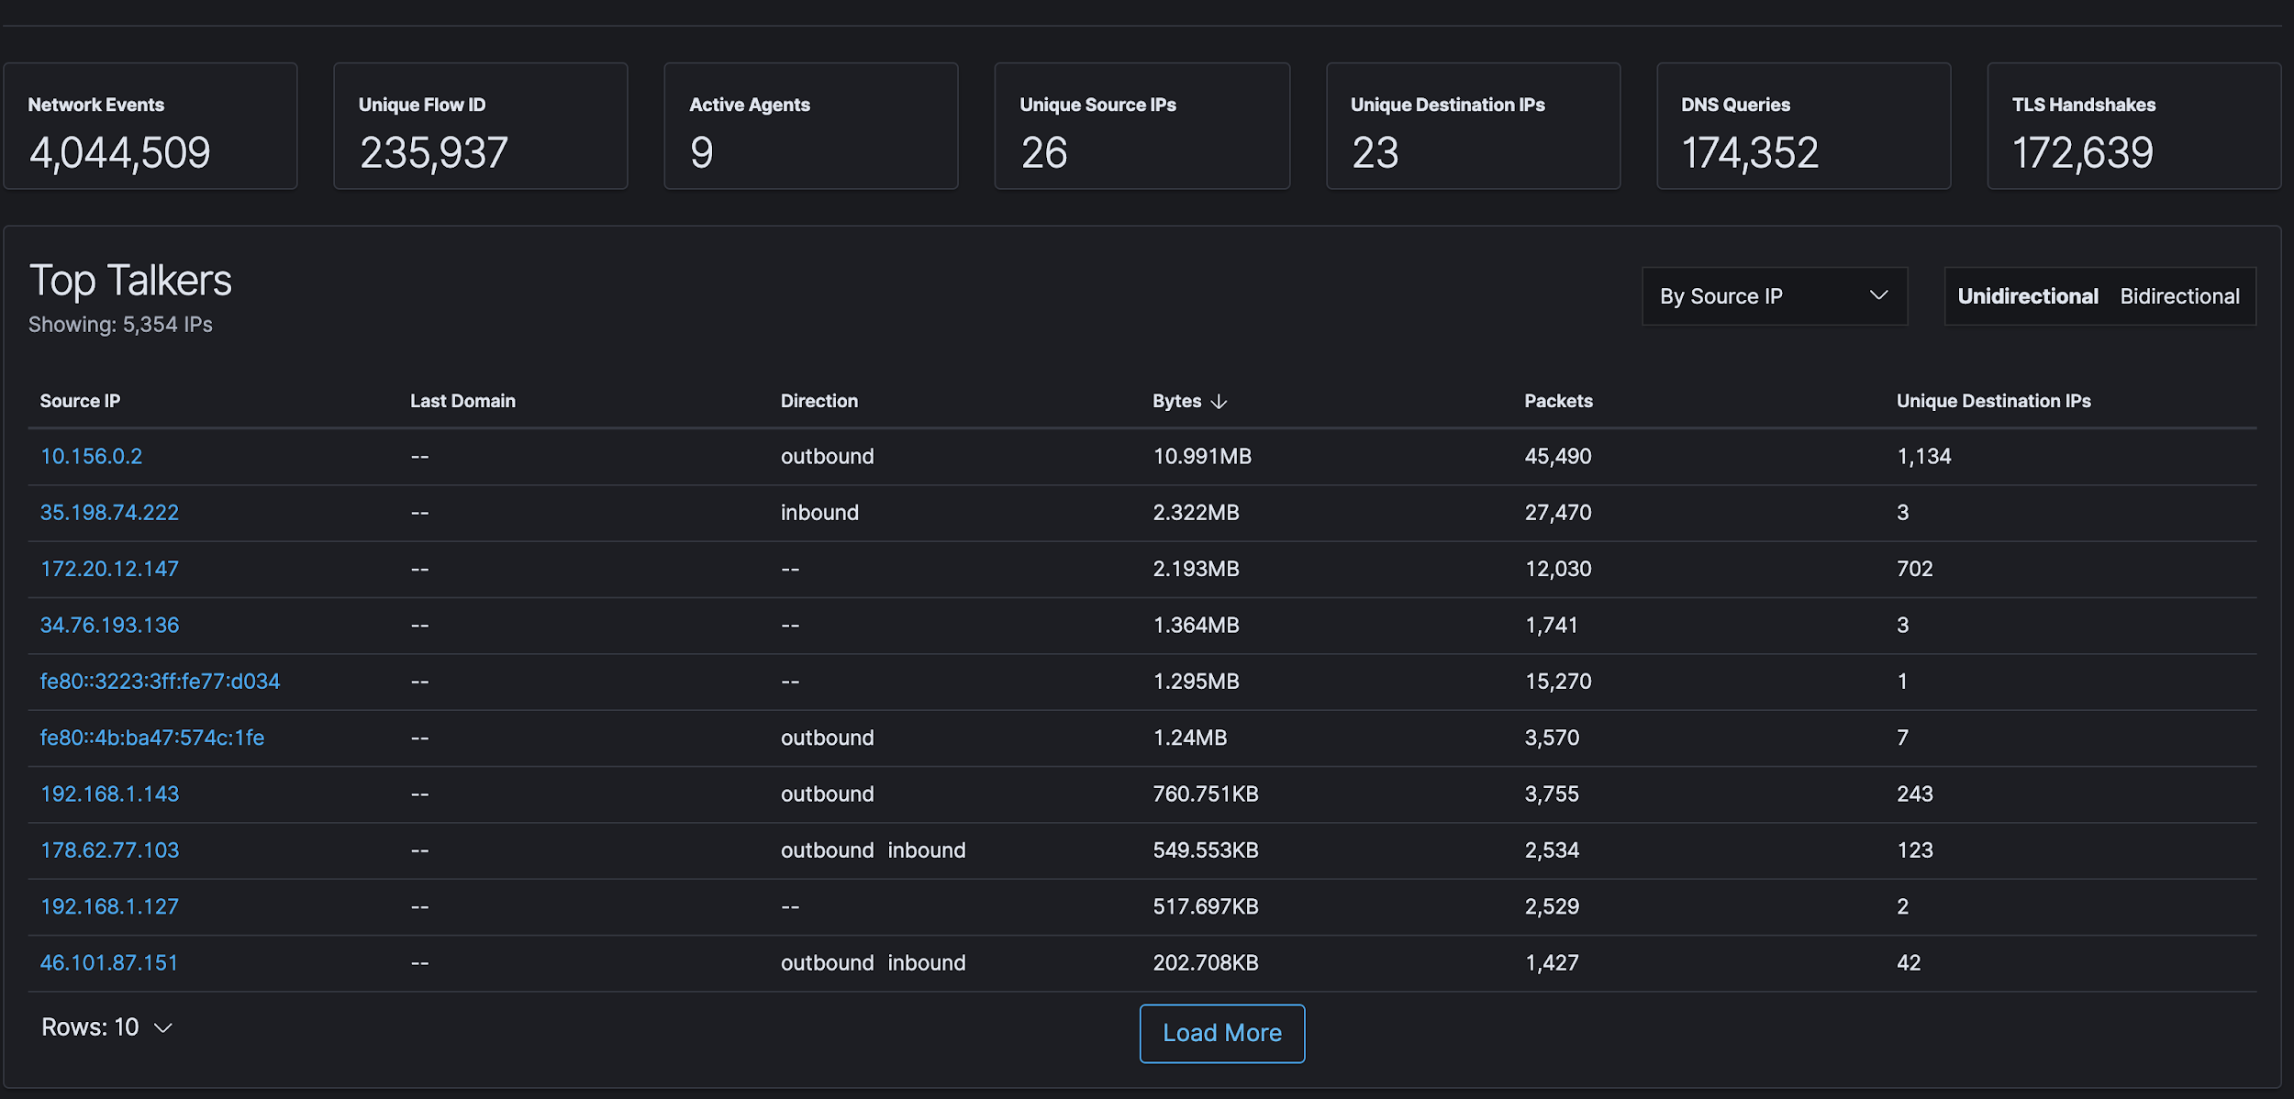

You can see that we are again presented with KPIs, this time related to network activity. We also have a table highlighting the “top talkers” (the IP addresses with the highest number of packets and bytes). Additionally, there is a list of the top domains being queries by DNS:

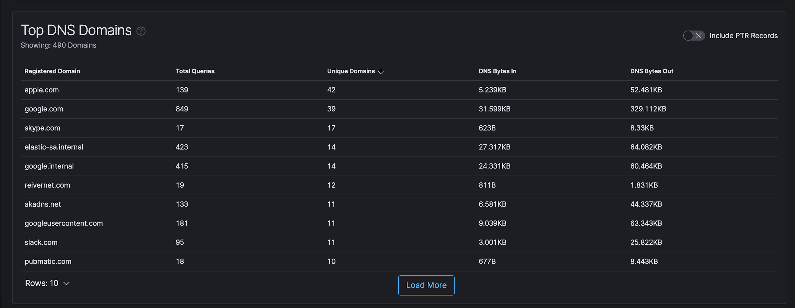

We can pick any IP address from the list of top talkers (or anywhere within the SIEM app) to drill down and get more information related to it. Go ahead and click on any IP address you like:

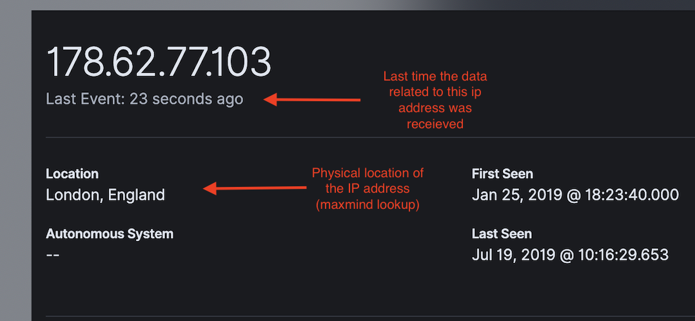

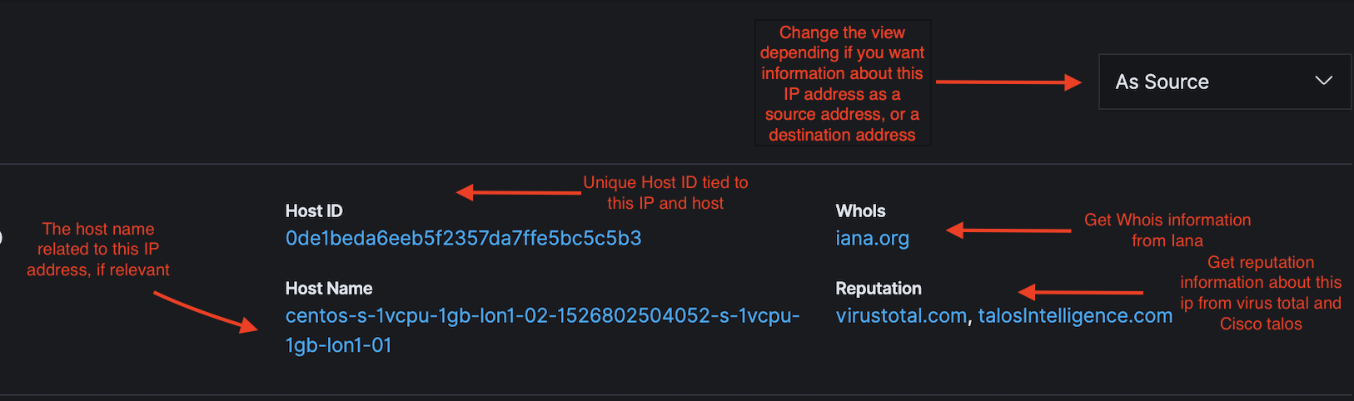

You will also notice some new tables when you drill down into an IP address: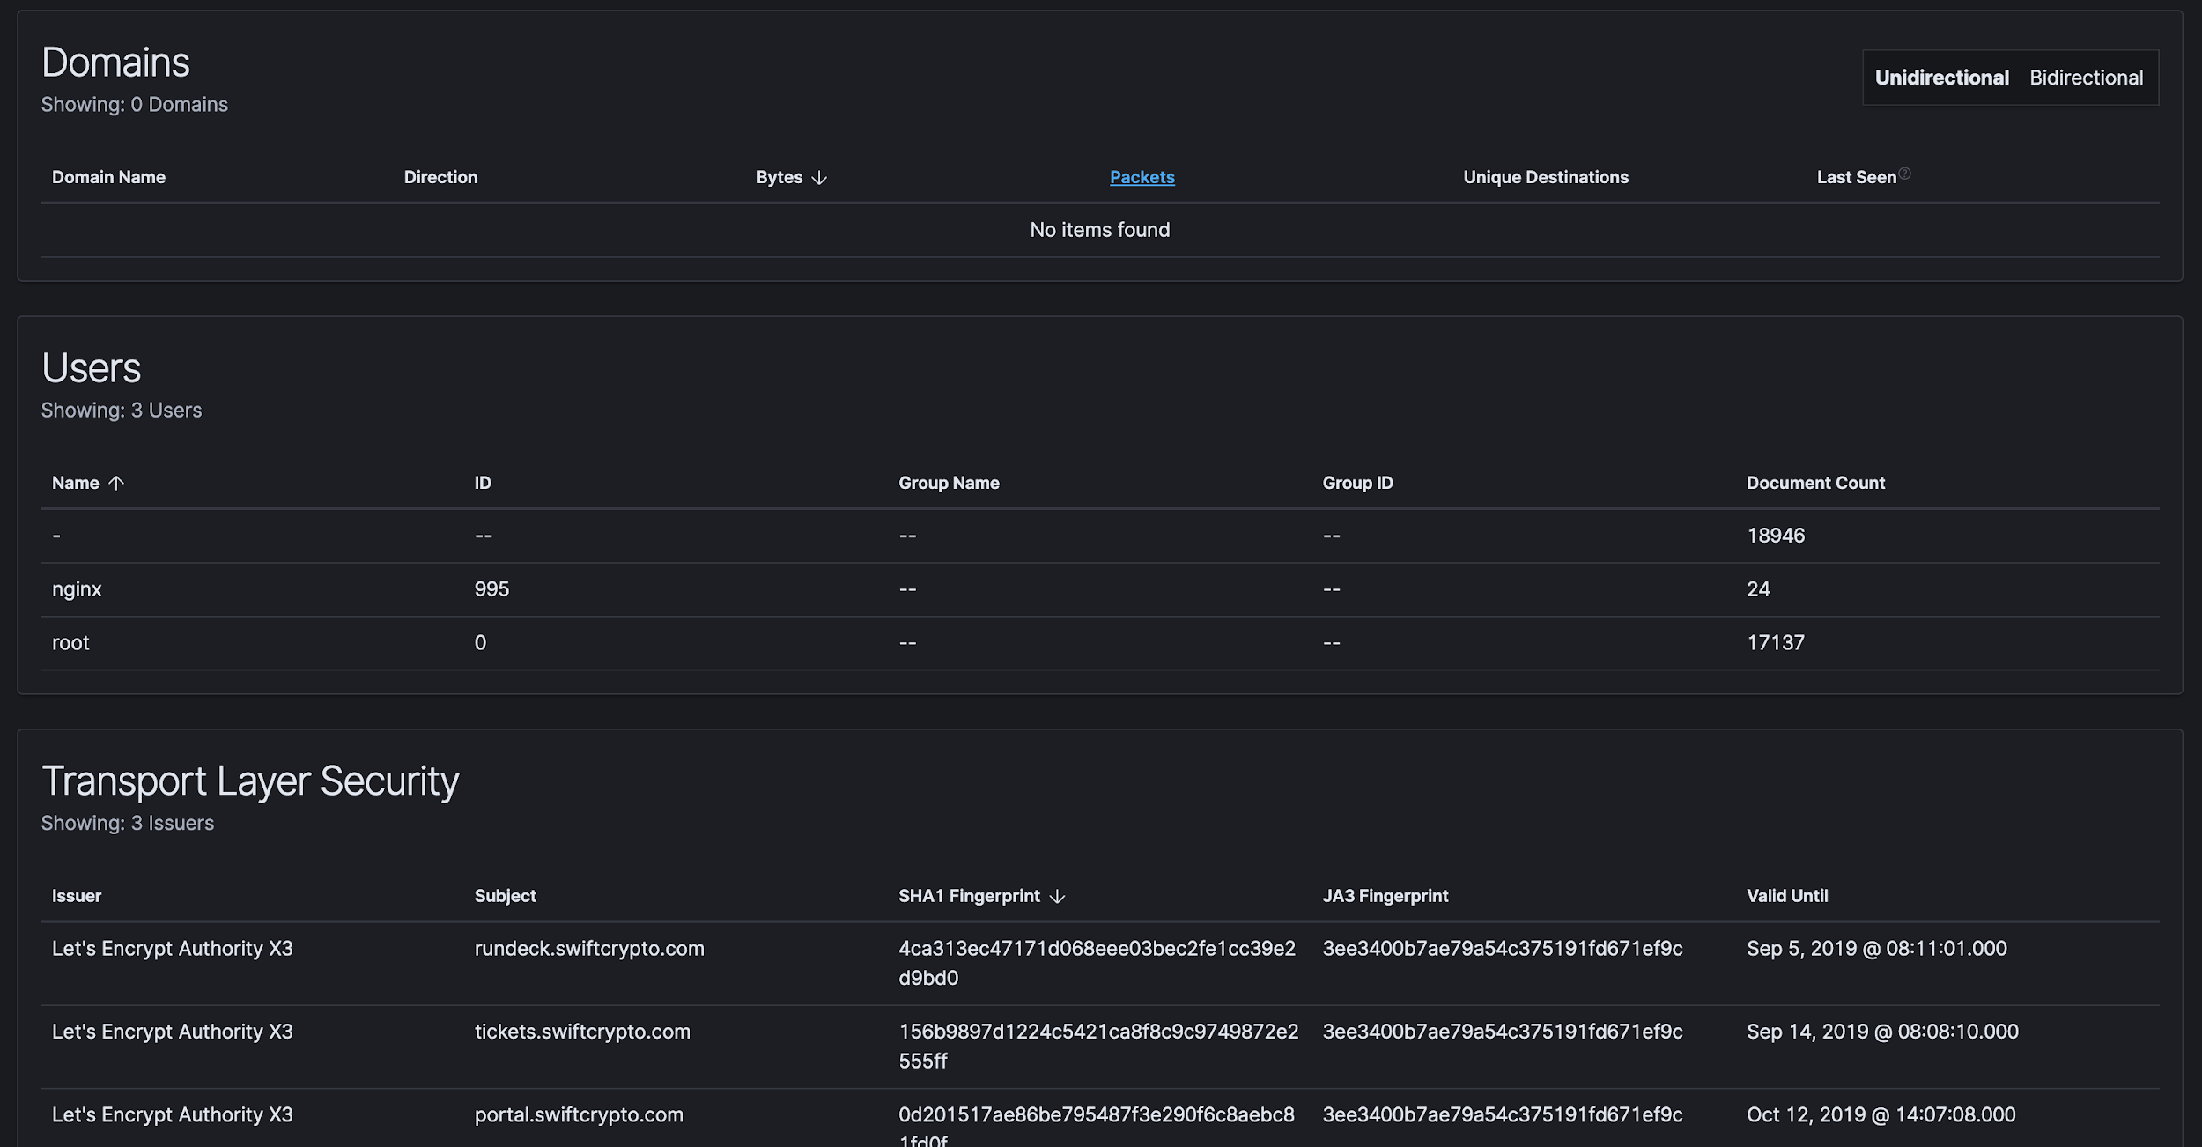

These tables show:

* Any domains related to the IP address
* Users running processes making request to/from this IP address
* Encrypted TLS connections being made to/from this IP address

Feel free to play around in both the hosts view and the network view. You might have noticed that we have a filter bar and a time picker at the top of every page. Feel free to also experiment with any filtering. Autocomplete will help you build a query.

Timeline view



## **Let us generate a port scan the using Nmap**

* If you are not aware of windows machine IP, type **ipconfig** in cmd

Or

* In your windows stigo , got to settings → machine info

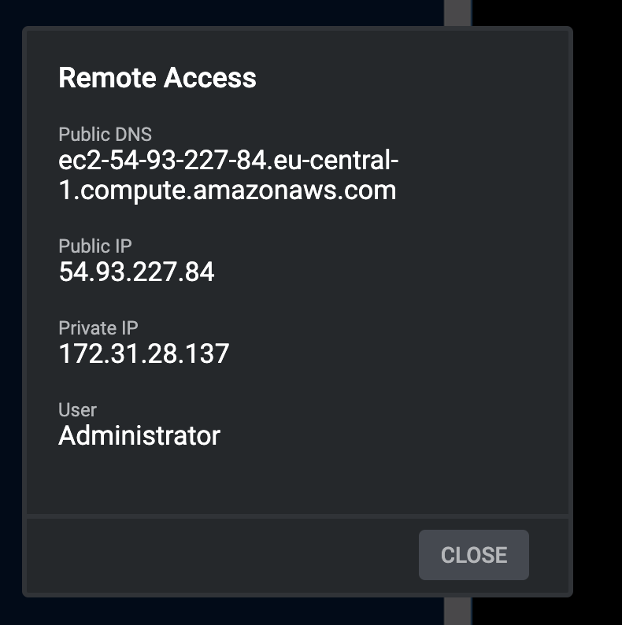

* In your Centos machine, type following command to scan the open ports on the windows machine IP.

nmap <windows machine IP>

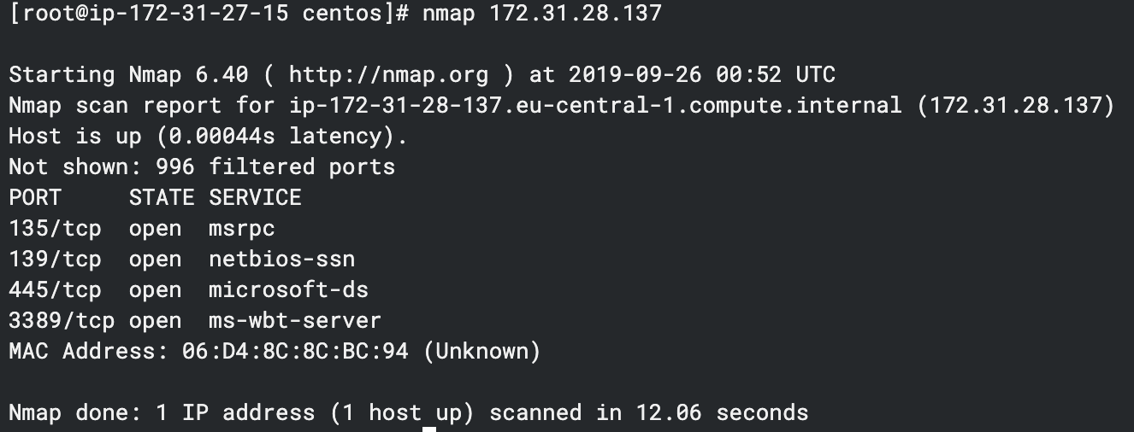

The ports are scanned for the targeted machine and the open ports are returned in results.

* Explore the events in SIEM app in kibana - navigate to your kibana SIEM timeline
* Type in process.name : nmap in filter bar [ it will give you auto complete and options while you are typing - this is powered by KQL (kibana query language) ]

